REST API

# Overview

## API (Application Programming Interface)

In general, an API provides an interface between two systems. Two systems can be two computers or devices or components that interacts programmatically through the API. APIs are often pull and push the data underneath user interfaces.

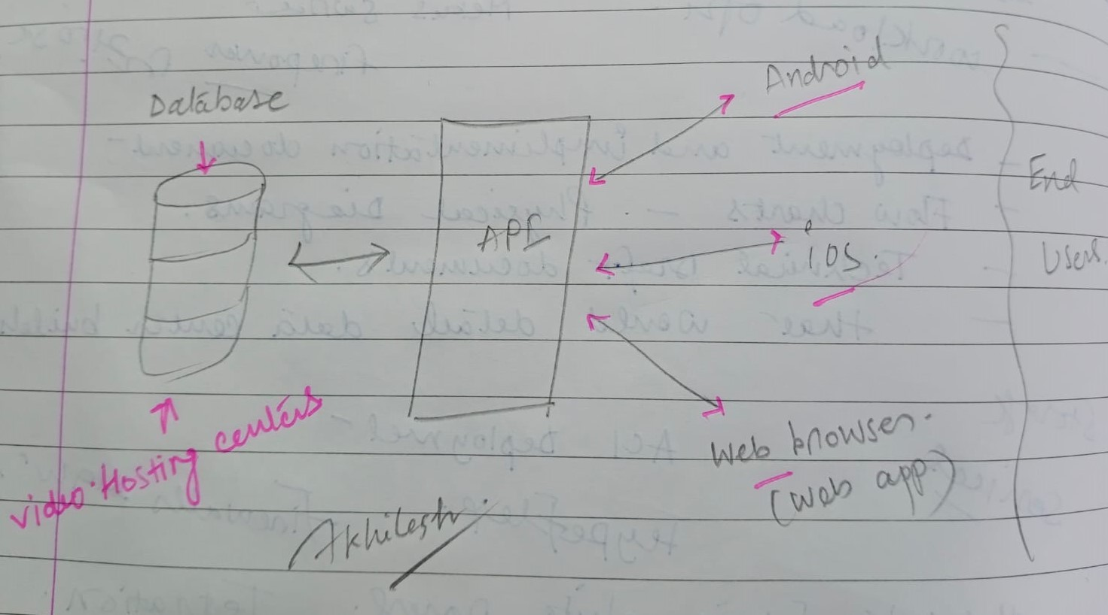

**Example –**

When you see a video embedded on a site, the site itself does not host the video. Instead, the embed code contains API requests that get the video from hosting centers.

## REST API

REST is an acronym for Representational State Transfer.

**A REST or RESTful API is an application programming interface that confirms or REST architectural style and allows for interaction with RESTful web services. It is the most popular style for building web APIs. REST determines specifications of the API through a set of rules that are followed when a REST API is created.**

### Guiding principles of REST

* Uniform Interface
* Client Server
* Stateless
* Cacheable
* Layered System
* Code on Demand

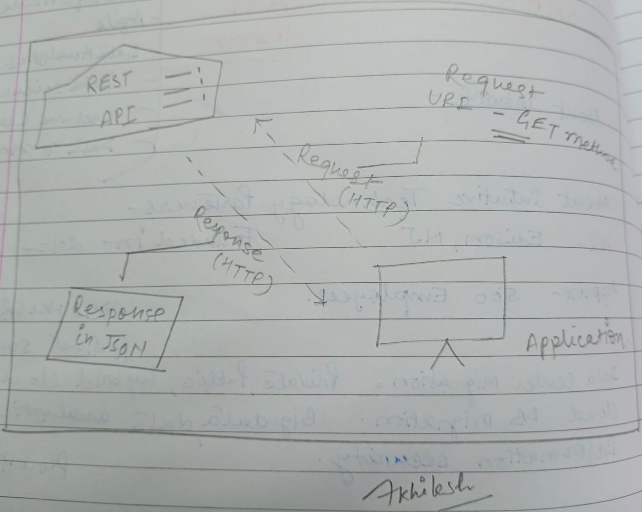

## How it works

A REST API works essentially the same way that any website does. A call is made from a client to a server, and data is received back over the HTTP protocol.

Facebook’s Graph API is an easy way to show the similarities between a REST API call and the loading of a webpage. Say someone wanted to pull up the Facebook page for YouTube, for example. That person would enter in the URL as normal, [www.facebook.com/youtube](http://www.facebook.com/youtube).

Perform the following steps to test the REST API:

1. Enter the URL of the API in the textbox of the tool.
2. Select the HTTP method used for this API (GET, POST, PATCH, etc).
3. Enter any headers if they are required in the Headers textbox.
4. Pass the request body of the API in a key-value pair.
5. Enter the required content type (such as application or JSON).
6. Click the send button.

After clicking Send, there will be various responses to the REST API, which details whether the API testing was a success or failure. It’s important to note the response code, response message, and response body.

## Common methods used in REST APIs

**GET** – Provides a read-only access to a resource.

**POST** – Used to create a new resource.

**DELETE** – Used to remove a resource.

**PUT** – Used to update an existing resource.

## Conclusion

APIs are critical in spanning technical and business boundaries to deliver data, capabilities, and services wherever (and whenever) they’re needed, but the design of APIs has shifted to the more lightweight and flexible varieties that are suited for mobile applications and geo-distributed networks.

Because of this approach, REST APIs continue to grow in popularity for mobile apps, social networking sites, and a variety of other offerings. Thousands of enterprises use REST APIs to generate business and grow their services, and REST API adoption will continue as one of the most efficient ways to enable the next generation of business applications.